**DEPT. OF ELECTRICAL & ELECTRONICS ENGINEERING SRM INSTITUTE OF SCIENCE AND TECHNOLOGY, Kattankulathur – 603203.**

|  |
| --- |
| Title of Experiment : **Clippers** |
| Name of the candidate : Debarghya Barik    Register Number : RA2011026010022    Date of Experiment : 19.11.2020 |

|  |  |  |  |
| --- | --- | --- | --- |
| Sl.  No. | Marks Split up | Maximum marks  (50) | Marks obtained |
| 1 | Pre Lab questions | 5 |  |
| 2 | Preparation of observation | 15 |  |
| 3 | Execution of experiment | 15 |  |
| 4 | Calculation / Evaluation of Result | 10 |  |
| 5 | Post Lab questions | 5 |  |
|  | **Total** | **50** |  |

**PRE LAB QUESTIONS**

1. **What are the differences between linear and nonlinear wave shaping circuit?**

**Ans:** In the **non-linear circuit**, the **non-linear** elements are an electrical element and it will not have any **linear** relationship **between** the current & voltage. In the **linear circuits**, the **linear** element is also an electrical element and there will be a **linear** relationship **between** the voltage and current.

1. **What are the applications of wave shaping circuit?**

**Ans:** The applications of Wave shaping.

* Integrator and Differentiator
* Wave modifications
* Adjusting DC Levels - Clipping & Clamping
* Pulse Timings [Multivibrators]

1. **What is wave shaping?**

**Ans:** The process by which non-sinusoidal waveforms are altered in passing through the **circuit** elements (such as diodes, resistors, inductors and capacitors) is called **wave shaping**. The **wave shaping** is used to perform any one of the following functions. To generate one **wave** from the other.

1. **What is the necessity of wave shaping?**

**Ans:** There are many cases in electronic circuits where signal or voltage waveforms other than sinusoidal ones are present. These waveforms include square waves, triangular waves, sawtooth waves or ramps, pulses of very short durations, and combinations of the above. So, according to our need the wave is modified using wave shaping circuits.

1. **Mention the application of clipper and clamper.**

**Ans:**

* Clipping is a process that operates by limiting the positive and/or negative amplitudes of a waveform so the process is also called limiting. Ordinary diodes, zener diodes, and transistors can be used to clip a voltage waveform.
* **Clampers** can be frequently used in removing the distortions and identification of polarity of the circuits. They are also used as voltage doublers and for modelling the existing waveforms to a required shape and range.

|  |  |
| --- | --- |
| **Experiment No. 8c) Date : 19.11.2020** | **CLIPPERS** |

**Aim**

To study the clipping circuits for different reference voltages and to verify the responses.

**Apparatus Required Components Required**

|  |  |  |  |  |  |  |  |  |
| --- | --- | --- | --- | --- | --- | --- | --- | --- |
| **S.No.** | **Name** | **Range** | **Qty** |  | **S.No.** | **Name** | **Range** | **Qty** |
| 1 | CRO | 1Hz-20MHz | 1 | 1 | Resistor | 10KΩ | 1 |
| 2 | RPS | (0–30) V | 1 |
| 3 | Bread  Board | **-** | 1 |
| 4 | Connecting  Wires | - | Req |  | 2 | Diode | IN4007 | 1 |
| 5 | Function  Generator | 1Hz-1MHz | 1 |  |

**Theory**

The non-linear semiconductor diode in combination with resistor can function as clipper circuit. Energy storage circuit components are not required in the basic process of clipping. These circuits will select part of an arbitrary waveform which lies above or below some particular reference voltage level and that selected part of the waveform is used for transmission. So they are referred as voltage limiters, current limiters, amplitude selectors or slicers. There are three different types of clipping circuits.

1. Positive Clipping circuit.
2. Negative Clipping.
3. Positive and Negative Clipping (slicer).

In positive clipping circuit positive cycle of Sinusoidal signal is clipped and negative portion of sinusoidal signal is obtained in the output of reference voltage is added, instead of complete positive cycle that portion of the positive cycle which is above the reference voltage value is clipped. In negative clipping circuit instead of positive portion of sinusoidal signal, negative portion is clipped. In slicer both positive and negative portions of the sinusoidal signal are clipped.

**Procedure**

1. Connect the circuit as shown in the circuit diagram.
2. Connect the function generator at the input terminals and CRO at the output terminals of the circuit.
3. Apply a sine wave signal of frequency 1 KHz, Amplitude greater than the reference voltage at the input and observe the output waveforms of the circuits.

**Circuit Diagram:**

# Positive Clipper

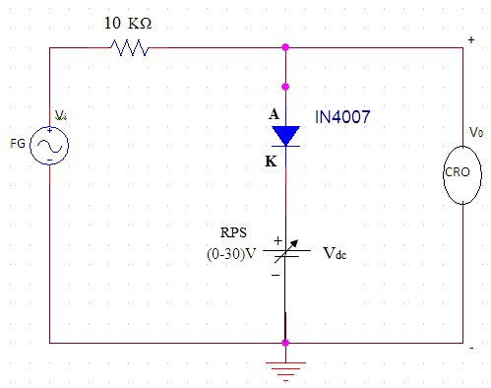

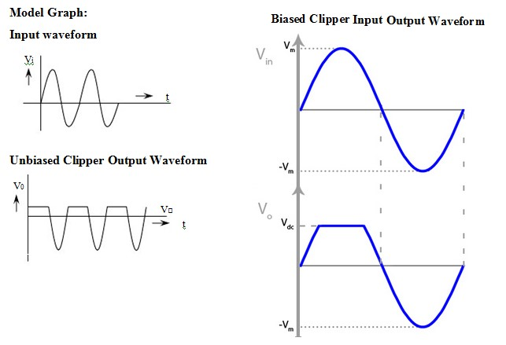

# Negative Clipper

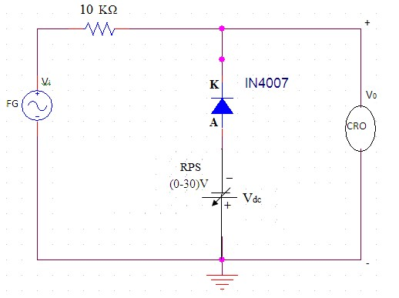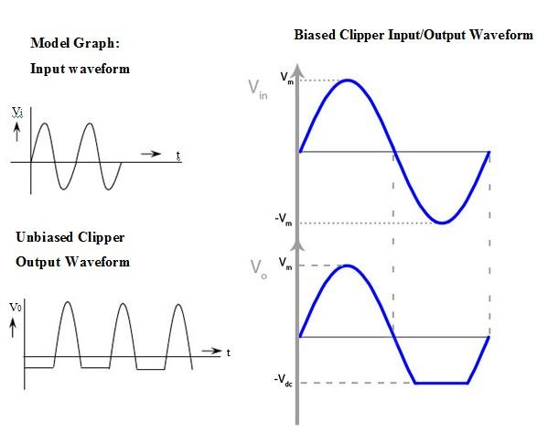

**E Circuit Diagrams:**

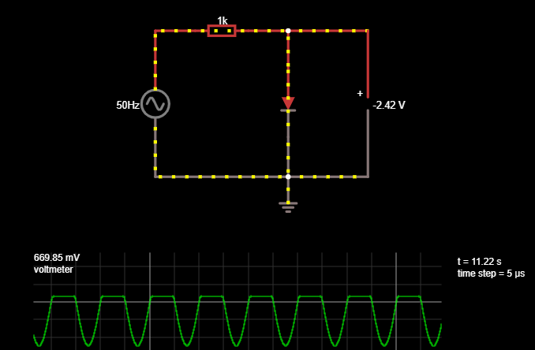

**Unbiased Positive Clipper**

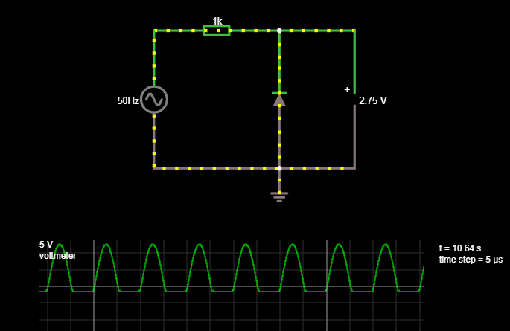

**Unbiased Negative Clipper**

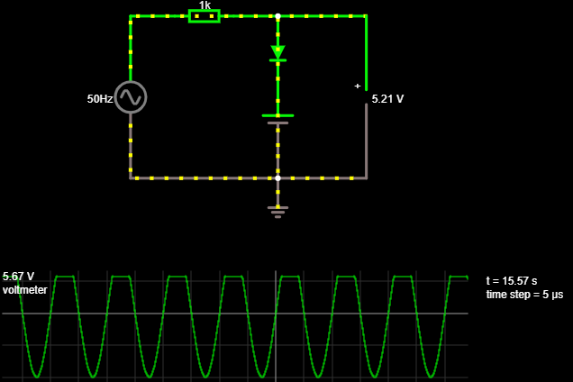

**Biased Positive Clipper**

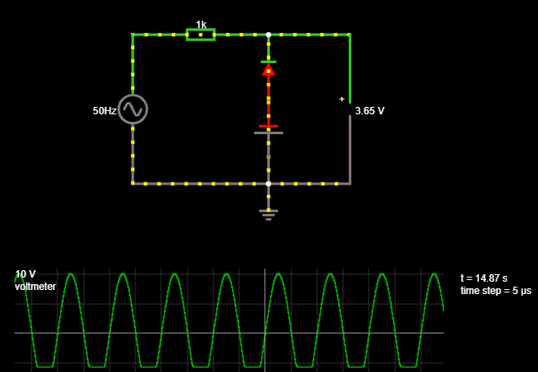

**Biased Negative Clipper**

**Tabulation:**

**Positive Clipper** **Negative Clipper**

|  |  |  |  |
| --- | --- | --- | --- |
| **Unbiased Clipper** | | | |
| **Vref = 0V** | | **Vref = 0V** | |
| **Output voltage**  **(V)** | **Time Period**  **(ms)** | **Output voltage**  **(V)** | **Time Period**  **(ms)** |
| 0.689 | 2 | -0.689 | 2 |
| **Biased Clipper** | | | |
| **Vref = 5V** | | **Vref = 5V** | |
| **Output voltage**  **(V)** | **Time Period**  **(ms)** | **Output voltage**  **(V)** | **Time Period**  **(ms)** |
| 5.67 | 2 | -5.67 | 2 |

**Graph:**

**1.** 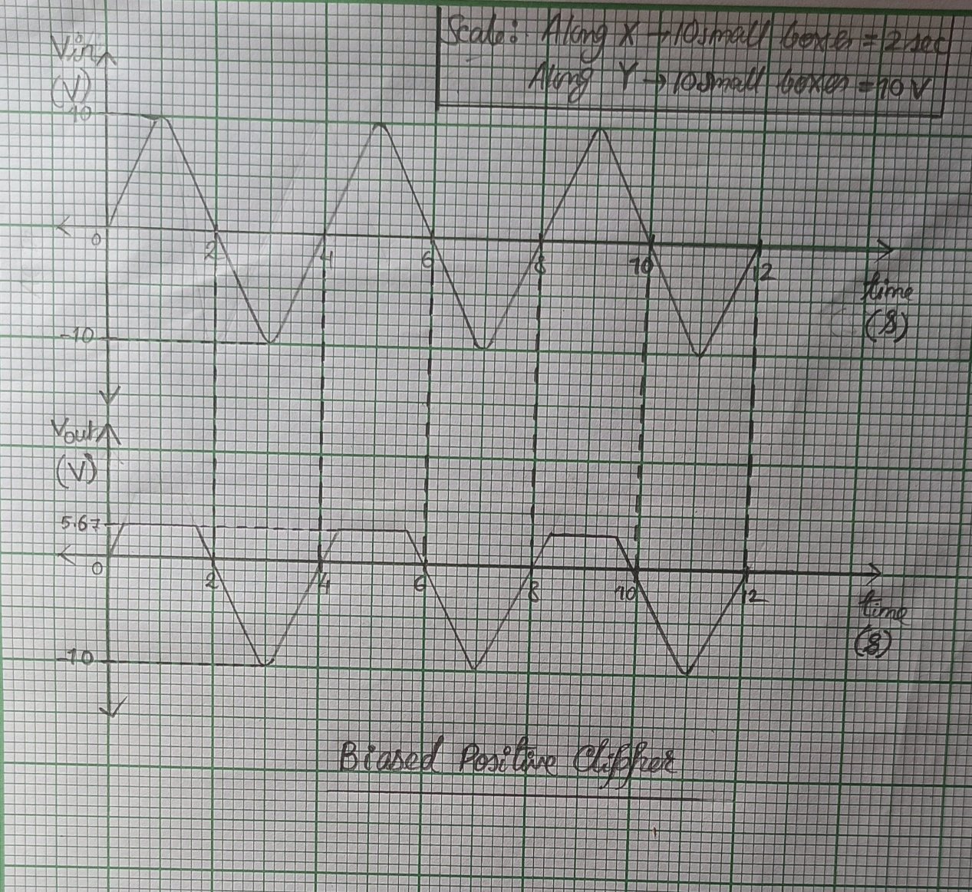

**Graph of Biased Positive Clipper**

**2.**

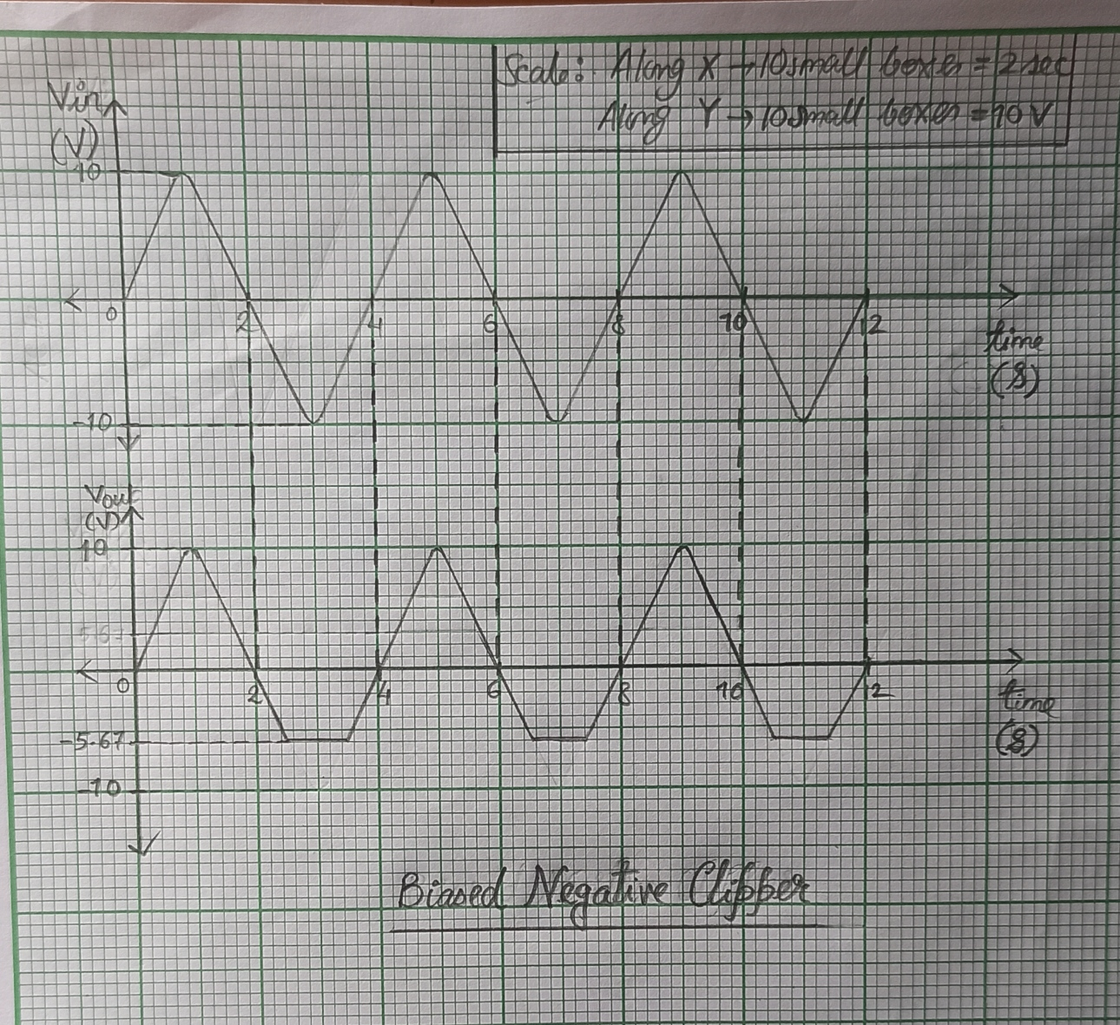

**Graph of Biased Negative Clipper**

**Result: The Characteristics of Biased and Unbiased Clippers are studied from the e-circuit simulations and the graphs.**

**POST LAB QUESTIONS**

1. **Differentiate +ve and -ve Clippers.**

**Ans:**

**Positive Diode Clipper:**

In a positive clipper, the positive half cycles of the input voltage will be removed in the output voltage.

***Negative Diode Clipper:***

The negative clipping circuit is almost the same as the positive clipping circuit, with only one difference. Here, the negative half cycles of the input voltage will be removed in the output voltage.

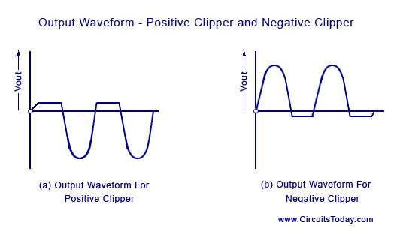

1. **What is the function of Clampers?**

**Ans:** A **clamper** is an electronic circuit that fixes either the positive or the negative peak excursions of a signal to a defined value by shifting its DC value. The **clamper** does not restrict the peak-to-peak excursion of the signal, it moves the whole signal up or down so as to place the peaks at the reference level.

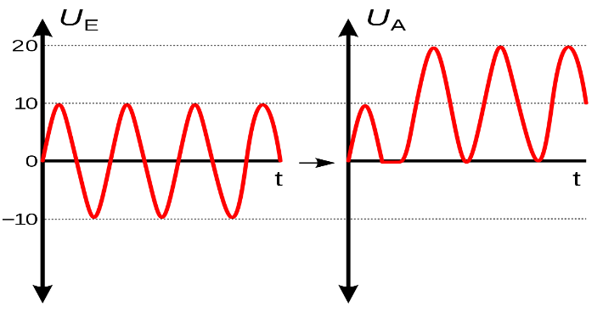

1. **Write the classifications of clippers and clampers.**

**Ans:** In general, clippers are classified into two types:

* Series Clippers

series negative clippers

series positive clippers

* Shunt Clippers

shunt negative clippers

shunt positive clippers

The clampers are classified as:

* + - * positive clampers
      * negative clampers

1. **Draw the output for the given input to the clamper circuit**

**Ans:**

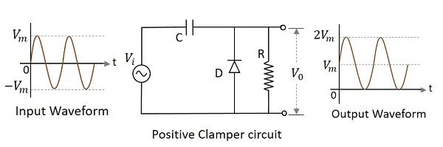

1. **What is the need of wave shaping circuit?**

**Ans:** A wave shaping circuit is the one which can be used to change the shape of a waveform from alternating current or direct current.

For example, a clipper circuit is used to prevent the waveform voltage from exceeding the predetermined voltage without affecting the remaining part of the waveform. This is nothing but wave shaping.

-----------------------------------------------------------------------------------------------------------